BLANDFORD FORUM
TOWN COUNCIL

Cllr C Tompsett
Chairman of Bryanston Parish Council Ref: T/P,S&F/Boundaries and CG
cllr.c.tompsett@bryanston-pc.gov.uk
Date: 22nd October 2021

Dear Cllr Tompsett

Community Governance Review

Following the Dorset Council public consultation announcement of the Community Governance Review, Blandford Forum Town Council resolved to form a working group to discuss possible boundary changes to the Blandford area. The group formulated the attached response, which was approved by full council at their meeting on 18th October 2021, Minute No. 92.5.

The Town Council accepts the recommendations from the working group (detailed at Appendix F) and includes consultation with the surrounding parishes when appropriate and requests the Dorset Council to chair and assist with the local conversation. A private meeting to discuss these ideas is welcomed.

The proposed response along with the above resolution will be sent to the Dorset Council.

I will be in touch again in due course to arrange a meeting to discuss the changes proposed by Blandford Forum Town Council.

Your faithfully,
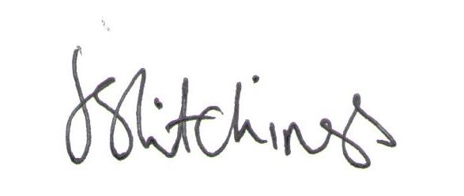
Cllr Lee Hitchings
Mayor of Blandford Forum 2021/22

Enc. Appendix F – Proposed Boundary Changes

Twinned with Preetz, Germany |  | Twinned with Mortain, France
Town Clerk’s Office  Church Lane, Blandford Forum  Dorset DT11 7AD |  | Tel: 01258 454500 • Fax: 01258 454432  Email: admin@blandfordforum-tc.gov.uk  www.blandfordforum-tc.gov.uk

Appendix F
Proposed Boundary Changes

Following the publication of the terms of reference for the Community Governance Review (22nd July 2021) Blandford Forum Town Council (BFTC) would like to put forward the following proposed boundary changes for consideration.

In this, BFTC has been guided by criteria from the Government Boundary Commission for England that:
- In the areas in question the identities and interests of the communities in those areas are reflected.
- The proposed changes are effective and convenient
- The impact on community cohesion is considered
- The impact on electorate size of future developments within the next five years is also taken into consideration.
Blandford Forum Town Council requests that consideration be given to changing its boundary so that all of the existing, current developments and planned developments in and around the immediate Blandford area would be incorporated within the town council’s boundary.

Boundary changes in Blandford occurred in 1984 and 2003. Since then, no boundary changes have taken place despite considerable development, especially in the Blandford St Mary area. The Boundary changes that occurred, at those times instigated by NDDC, sought to incorporate the then recent contiguous and proximal growth in the Blandford area, thereby achieving a logical cohesiveness of settlement and to facilitate ease of administration. The proposals detailed below seek to achieve the same.

PROPOSED CHANGES IN DETAIL (estimates of ward councillors required is based upon a population figure of 675.5 for 1 ward councillor – the existing figure for Blandford Forum)

Move from Pimperne Parish to Blandford Forum Parish:
- The triangle of land between the Blandford bypass and the Milldown Road. The retention of this boundary would be irrational and detract from community cohesion. Local services and schools in Blandford are in close proximity whereas the centre of Pimperne is over a mile away. No additional wards would need to be created and the area could be incorporated into the BFTC ward of Hilltop.

- The land to the north and east of Blandford, allocated for development within the next five years, (Draft Dorset Local Plan 2021) to the north east of Blandford, where 200 homes plus attenuation ponds are planned, within Pimperne, as part of a much larger development of 400 homes in close juxtaposition and relating to this development, within the boundary of the parish of Blandford. It would be illogical to have part of one whole development within another parish. Incorporating this area within Blandford would facilitate easier administration and governance of the whole new estate, when the development is signed over from the developer. The proposed routes to and from this estate, and the schools and services relate to Blandford Forum. This would be a logical rationalisation of the boundary and significantly leave a gap between Blandford’s parish boundary and the centre of Pimperne. The additional houses would create one new ward for 2 councillors or the ward boundary for Blandford Badbury Heights Ward could be moved to incorporate this area with 2-3 councillors representing the new area.

Move from Langton Long parish to Blandford Forum Parish:
The whole parish of Langton (see map). This change would enable cohesive and rational governance of an area, with very few buildings which rely on Blandford for services and schooling and is immediately adjacent to the town. Dorset Council in their area profile for Blandford Forum & Langton Long Blandford combined the populations of both parishes. It would be logical to combine the governance of both as well. No new wards would need to be created.

Move from Tarrant Launceston and Tarrant Monkton parishes to Blandford Forum Parish:
- All areas of Blandford Camp within the perimeter of Blandford Camp. The boundaries here are historic and bear no relation to the current socio-geographical relationship in 2021. The name itself is an indication of the close relationship that Blandford Camp has with the town. Blandford is the principal focus for services, recreation and secondary schooling for residents of the camp. By having Blandford Camp represented by councillors would enable a forging of even closer cohesive links than currently exist and give a voice to the interests of the Blandford camp community. The change would create a new ward of 3 councillors.

Move from Blandford St Mary Parish and Bryanston Parish to Blandford Parish:
- The entire current boundary of Blandford St Mary and Bryanston much of which is in close proximity to Blandford St Mary. In their Draft Local Plan, Dorset Council (2021) in terms of development and proposed development, have regarded the whole of the local Blandford area in closest geographical proximity as one. This includes the parishes of Blandford St Mary and Bryanston. The rapid growth in recent and current developments of homes in Blandford St Mary, leading to an additional 600 plus, combined with development which took place in the 1990s, has completely altered the nature of Blandford St Mary as a village to the point where it is no longer a distinct and cohesive settlement. In effect, all of the existing houses, business and commercial buildings and new developments are an extension of Blandford town. Both Blandford St. Mary and Bryanston parishes rely almost solely on Blandford for goods services, sport and recreation. A notable example of this is Blandford skate park - although in the parish of Blandford St Mary, the skate park was originally funded and is fully maintained by BFTC.

- The parish boundary line, following the course of the River Stour, now appears to be a historical vestige which is arbitrary, obsolete and illogical. With the omission of the river and flood plain Blandford St Mary and Bryanston, are contiguous with Blandford Forum. With the exception of a supermarket, a brewery shop and cafe and a primary school, the residents of Blandford St Mary also rely almost solely on Blandford for services, with strong pedestrian, cycle and road links back to the primary settlement. The current and proposed developments have placed additional burdens on Blandford’s services. Service provision can be enhanced and more easily augmented if Blandford becomes a larger settlement.

- The proximity of Blandford St Mary residents to Blandford’s business centre is such that the majority live closer to Blandford centre than do many residents of Blandford who live in the northern part of the parish. The propose change would give a greater cohesiveness to Blandford. It would secure the long-term sustainability of the town as the principal service town of the region and thereby attract more businesses and services; it would ease administration and facilitate the passage of local decisions affecting the whole of the community that relates to Blandford. This change would create new distinct wards (‘Blandford St Mary’ and Bryanston) for up to 4 councillors.
Taken as a whole, the changes if implemented would create the need for 9 (?) new councillors giving a total of 25 councillors for Blandford Forum Town Council* serving a total population of approximately 18,000 people (see below). It would centralise administration in Blandford, create an economy of scale, sustain Blandford as the principal settlement in an environmentally sensitive area, and give cohesiveness to the whole community that relate closely to Blandford town. The area thus created would be a mixture of rural and urban which would best serve the business and employment, environmental and infrastructure needs of the community that relates directly to Blandford.

The estimated current population of the proposed area is approximately 13,400. With the additional houses currently being built or planned, that population is likely to rise between 3000 and 4000 over the next five years. This would then give a total population of approximately 18,000, resulting in a modest sized settlement between Bridport (est. 14,708 in 2020) and Dorchester (est. 21,438 in 2020). This is a sustainable figure for the status of Blandford as the principal service town for the region.

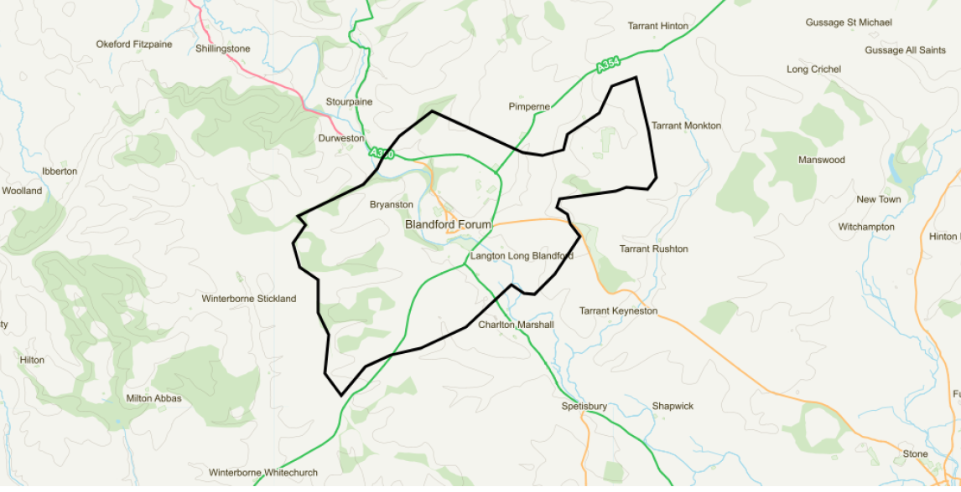

* There may be a need to rationalise the number of ward Councillors for the whole of the Blandford area in line with other Dorset towns (e.g. Dorchester with 20 Councillors representing a population of 21,500 (est.2019).

